Harsh Kasliwal

2003085

C21

**EXPERIMENT 2**

**Q1. Write a Python Program to:**

1. Read an array and display
2. Append a new item to the end of the array
3. To reverse the order of the items in the array (slice operator)
4. Get the length in bytes of one array item
5. To append items from another array
6. Remove a specified item using the index from an array
7. Insert a specified item at the specified position in the array

**THEORY:**

1. Creating an array in Python:

Array in python can be created by impacting array module array (data type, value_list) is used to create an array with data type & value list exp specified in its argument

1. append():

The append() method adds an item to the end of list

Syntax:

list.append (item)

1. Reversing using slice operator

The slice() function returns a slice object that is used to slice any sequence (string, list, range or byte)

Syntax:

Slice(start, stop, step)

Reversing an array:

To reverse an array, we can use the reverse() function But we can also do using slicing. Here a copy of the list is made & the list is not sorted

We can do like this:

list[ : : -1 ]

1. Length in bytes of one array item

Pandas ‘series itemsize’ attribute return the size of the data type of the item of the underlying data for the given series

Syntax:

Obj.itemsize

1. Removing an element from specified index

The pop() method removes the item at the given index from the list & returns the removed item

Syntax:

list.pop(index)

1. Inserting specified item at specified index

The insert() method inserts an element to the list at the specified index

Syntax:

list.insert( i, element )

Here element is inserted to the list at the ith index & all the elements after element are shifted to the right

**CODE:**

**Q1**

**i)**

import array as s

a=s.array('i',[])

n=int(input("Length of the array is : "))

for i in range(0,n):

a.append(int(input("Element {}: ".format(i+1))))

print(a)

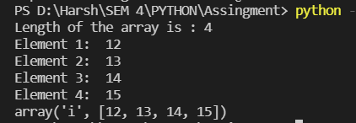

**ii)**

import array as s

a=s.array('i',[])

n=int(input("Length of the Array is??? "))

for i in range(0,n):

a.append(int(input("Element {}: ".format(i+1))))

b=int(input("Enter the element to be appended : "))

a.append(b)

print(a)

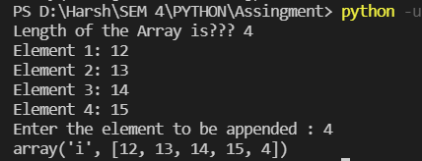

**iii)**

import array as s

a=s.array('i',[])

n=int(input("Length of the array is : "))

for i in range(0,n):

a.append(int(input("Element {}: ".format(i+1))))

#slicing

print("\n{}".format(a))

s1=a[::-1]

print("\nAfter slicing array will be ----> {}\n".format(s1))

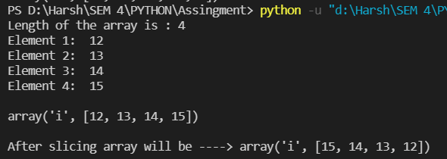

**iv)**

import array as s

a=s.array('i',[])

n=int(input("Length of the array is : "))

for i in range(0,n):

a.append(int(input("Element {}: ".format(i+1))))

print("Length in bytes of one array item {}".format(a.itemsize))

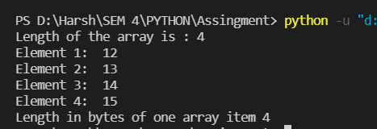

**v)**

import array as s

a=s.array('i',[])

b=s.array('i',[])

n=int(input("Length of the array is : "))

for i in range(0,n):

a.append(int(input("Element {}: ".format(i+1))))

m=int(input("Length of the array is: "))

for i in range(0,m):

b.append(int(input("Element {}: ".format(i+1))))

for i in b:

a.append(i)

print(a)

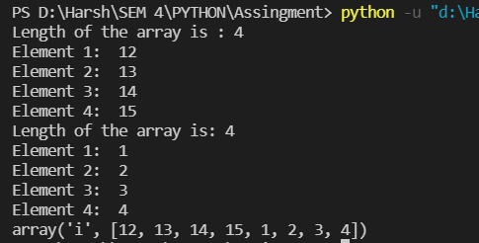

**vi)**

import array as s

a=s.array('i',[])

n=int(input("Length of the array is : "))

for i in range(0,n):

a.append(int(input("Element {}: ".format(i+1))))

print(a)

m=int(input("Enter the index of element to be popped from array : "))

a.pop(m)

print("Array after popping ")

print(a)

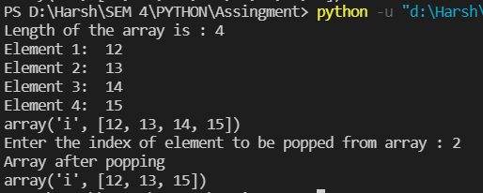

**vii)**

import array as s

import array as s

a=s.array('i',[])

n=int(input("Length of the array is: "))

for i in range(0,n):

a.append(int(input("Element {}: ".format(i+1))))

print(a)

m=int(input("Enter the element to be inserted: "))

p=int(input("Enter the index to be located: "))

a.insert(p,m)

print(a)

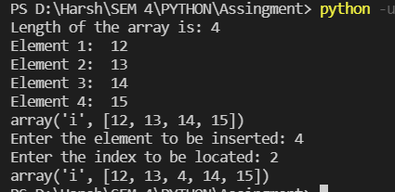

**Q2. Write a Python program to remove prime numbers from an array**

**THEORY:**

The remove() method removes the first matching element (which is passed to an argument) from the list

Syntax:

list.remove()

Parameters:

* The remove() method takes a single element as an argument & removes it from the list
* If the element doesn’t exist it throws [valueError: list remove(x):x not in list ] exception

Return

The remove() doesn’t return any value

**CODE:**

import array as s

import array as s

a=s.array('i',[])

b=s.array('i',[])

n=int(input("Length of the array is: "))

for i in range(0,n):

a.append(int(input("Element {}: ".format(i+1))))

b.append(2)

for i in a:

for j in range(2,i):

if(i % j==0):

break

if(j==i-1):

b.append(i)

for j in b:

while j in a:

a.remove(j)

print(a)

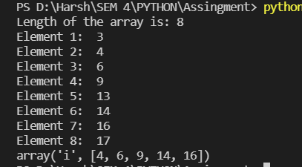

**Q3. Write a Python program to change all occurrences of a first character of a string to ‘@’ except for first occurrence**

**Theory:**

replace()

The replace() method replaces each matching of the old character / text in the string with character / string

Syntax:

Str replace(old, new [count ])

Parameter

* old: old substring you want to replace
* new: new substring which will replace old
* count(optional): the numbers of times you is replace the old substring with new substring with new substring

Note: If count is not specified the replace() replaces all occurrence of old substring with new

Return value

The replace() method returns a copy of the where the old substring is replaced to new

replacing, skipping first occurrence using slicing we perform the task of replacing entire str 2nd character with ‘@’ of the character occurring first index. The result is the prefix concatenate

**CODE:**

a = str(input("Enter the string: "))

print("The original string is: " + a)

b = a[0] + a[1:].replace(a[0], '@')

print("Replaced String: " + str(b))

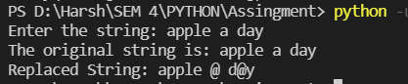

**Q4. Write a Python Program**

* to sort group of strings in alphabetical order
* to check whether entered string is palindrome or not

**THEORY:**

sort()

The sort() method sort elements of a given list in a specific ascending or descending order

Syntax;

list.sort(key: ……, reverse:…..)

Parameters

By default, it doesn’t require any extra parameters. However it has 2 optimal parameter reverse: If true, the sorted list is reversed key: function that serves as a key for the sort comparison

Return value:

The sort() method doesn’t return any value it changes the signed list. If you want a function to return the sorted list rather than change the original list use sorted()

Palindrome: A palindrome is string that is same read forward or read backward.

For ex: “nitin” is the same in forward or backward

**CODE:**

**4a:**

a = ["Harsh", "Kasliwal", "Virat", "Kholi", "Surya"]

x = sorted(a)

print(x)



**4b:**

str1 = str(input("Enter the string : "))

str2 = reversed(str1)

if list(str1) == list(str2):

print("The string is a palindrome.")

else:

print("The string is not a palindrome.")

